NODE-RED SERVICE

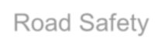

|  |  |
| --- | --- |
| Date | 01 November 2022 |
| Team ID | PNT2022TMID12612 |
| Project Name | Signs with Smart Connectivity for Better Road Safety |

